Amazon | OA 2020 | Maximum Units

LEETCODE : <https://leetcode.com/discuss/interview-question/793606/Amazon-OA-Question>

https://leetcode.com/discuss/interview-question/793606/Amazon-OA-Question

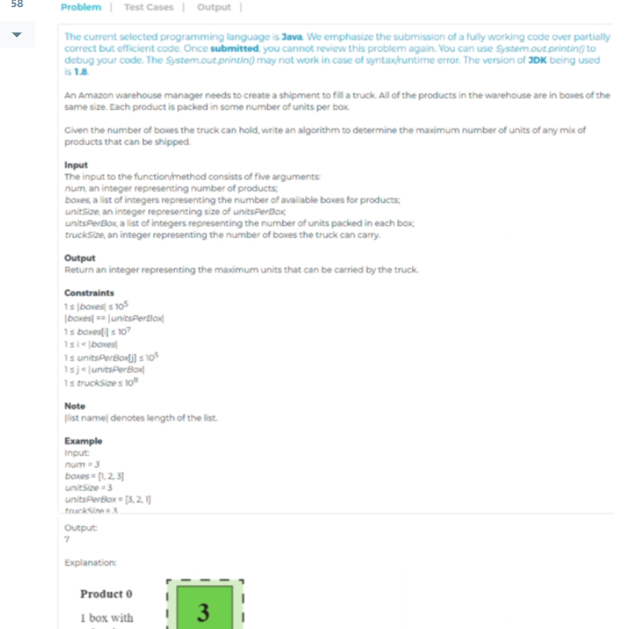

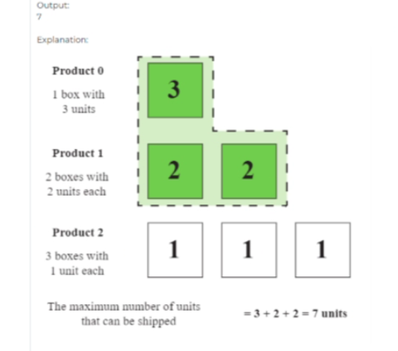

public static long getMaxUnits(List<Long> boxes, List<Long> unitsPerBox, long truckSize) {

// key: size, value: idx

// sort by units per box

// get number of boxes from map based on size

Map<Long, Long> map = new HashMap<>();

for (int i = 0; i < boxes.size(); i++) {

Long boxIdx = boxes.get(i);

Long size = unitsPerBox.get(i);

map.put(size, boxIdx);

}

Collections.sort(unitsPerBox, Collections.reverseOrder());

long res = 0;

for (Long boxSize : unitsPerBox) {

// greedy fill the truck with the highest value boxes

Long boxCount = map.get(boxSize);

if (truckSize < 0) {

return res;

}

// if we have exact space in the truck for all packages of this size

if (truckSize == boxCount) {

res += (boxCount \* boxSize);

return res;

}

// if space is still left, add to result, and decrement truck size by expected amount

if (truckSize > boxCount) {

res += (boxCount \* boxSize);

truckSize -= boxCount;

} else {

res += (truckSize \* boxSize);

return res;

}

}

return res;

}